Week 2 – Buildathon

This application crawls and creates a knowledge base for any given valid website URL and extracts the information from the knowledge base for the user query.

Step-by-step procedure followed to generate the GenAI Application

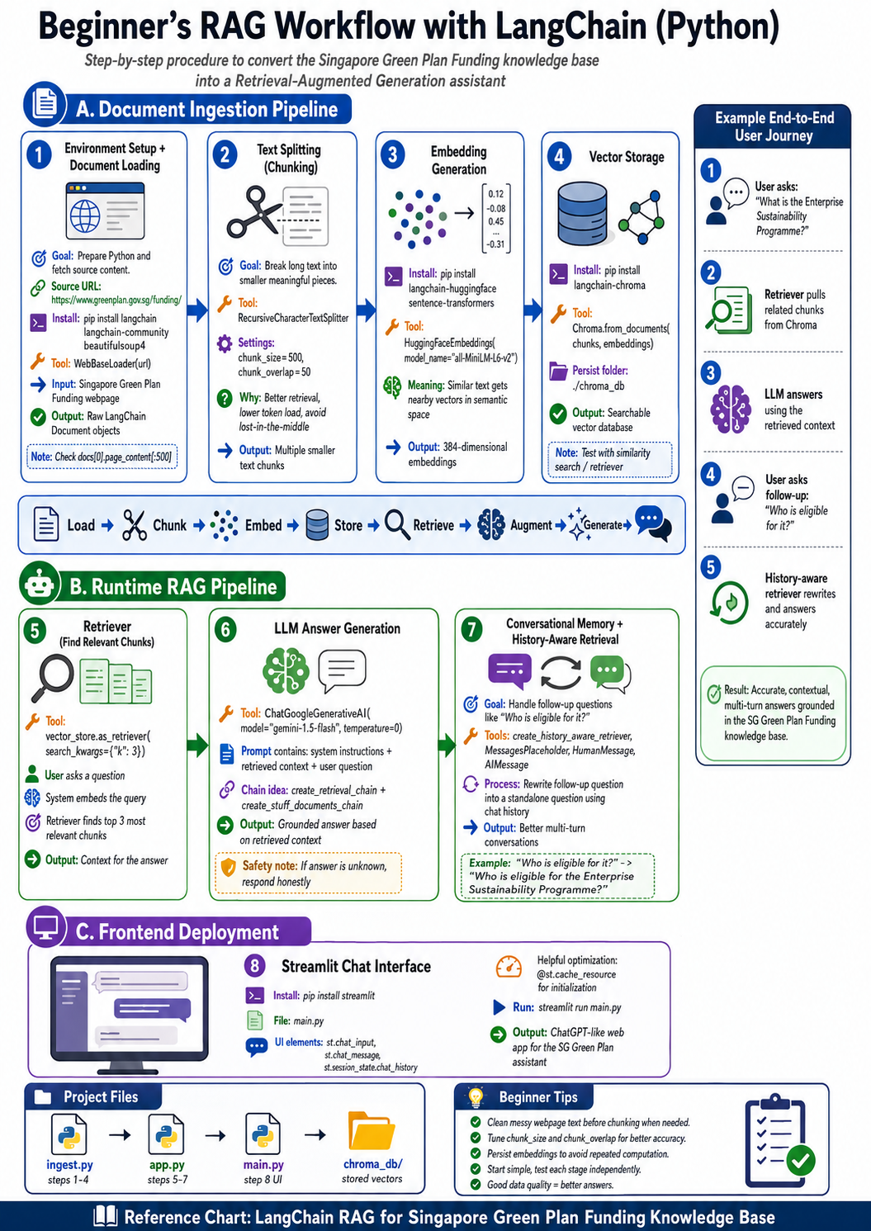

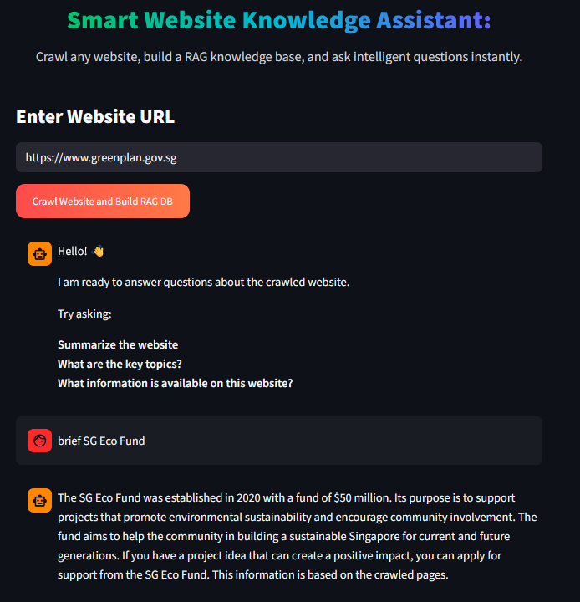

Outcome of the Step-by-Step procedure

Conversation with Gemini
I want to build a rag application using langchain in python
My problem statement is that the Singapore welcome scheme (https://www.greenplan.gov.sg/funding/) is a detailed knowledge base, which has to be converted into RAG.
I am totally new to this concept. Help me to implement the "step-by-step" procedure. One step at a time.
RAG pipeline - Document pipe-lining.
Welcome to the world of AI and LangChain! Building a RAG (Retrieval-Augmented Generation) application is an excellent way to handle large knowledge bases like the Singapore Green Plan (Funding Scheme).
Since you are completely new to this and requested a "step-by-step, one step at a time" approach, let's look at the overview of the Document Pipe-lining (the ingestion phase) first, and then we will write code for just the very first step today.

The Document Pipe-lining Workflow
Before jumping into code, here is how a RAG ingestion pipeline processes a knowledge base website:
- Document Loading: Fetching data from the source (e.g., scraping the website or loading downloaded PDFs/HTMLs).
- Text Splitting (Chunking): Breaking large blocks of text into smaller, readable paragraphs so the AI doesn't get overwhelmed.
- Embedding Generation: Converting those text paragraphs into numbers (vectors) that capture mathematical meaning.
- Vector Storage: Saving those numbers into a specialized database (Vector Store) for instant searching later.

Step 1: Setting up your environment and Document Loading
The absolute first thing we need to do is prepare your Python environment and download the content from the website so LangChain can understand it.

1. Install the required Python packages
Open your terminal or command prompt and run the following command to install LangChain and its web scraping companion:
Bash
pip install langchain langchain-community beautifulsoup4

2. Python Code to Load the Webpage
LangChain provides built-in tools called DocumentLoaders. For a website like the Singapore Green Plan, we will use the WebBaseLoader.
Create a python file (e.g., rag_pipeline.py) and write this initial code:
Python
from langchain_community.document_loaders import WebBaseLoader

# Step 1: Define the target URL (Singapore Green Plan Funding Page)
url = "https://www.greenplan.gov.sg/funding/"

print("🔄 Loading document from the web...")
# Initialize the loader
loader = WebBaseLoader(url)

# Load the page data into LangChain's internal "Document" format
docs = loader.load()

# Let's inspect what we extracted
print(f"✅ Successfully loaded {len(docs)} document object.")
print("\n--- Snippet of the Raw Text Extracted ---")
# Print the first 500 characters to ensure it worked
print(docs[0].page_content[:500].strip())

Try this out!
Run this script in your environment. It should fetch the text elements of the webpage and display the initial introductory text containing keywords like "SG Eco Fund", "3R Fund", or "Enterprise Sustainability Programme".
Let me know once you have successfully installed the packages and run this code, or if you encounter any errors! Once you are ready, we will proceed to Step 2: Text Splitting (Chunking).
done
Awesome! You've successfully managed Step 1 (Document Loading). Now you have the raw text from the Singapore Green Plan website sitting in your script's memory.
If you look closely at that raw text, it is likely thousands of words long. If we pass this entire massive wall of text to an AI model at once, it will be slow, expensive, and the AI might lose track of specific details (a phenomenon known as "lost in the middle").
Let's move on to Step 2: Text Splitting (Chunking).

Step 2: Text Splitting (Chunking)
In this step, we break that massive document into smaller, meaningful paragraphs (called "chunks").
We will use LangChain's RecursiveCharacterTextSplitter. This tool is smart: it attempts to split text by paragraphs first, then sentences, and finally words if necessary, keeping related information together.

Update your Code
Add the following code to your rag_pipeline.py file to split your document:
Python
from langchain_community.document_loaders import WebBaseLoader
# New Import for Step 2
from langchain_text_splitters import RecursiveCharacterTextSplitter

# --- STEP 1: LOAD (Already Done) ---
url = "https://www.greenplan.gov.sg/funding/"
loader = WebBaseLoader(url)
docs = loader.load()

# --- STEP 2: TEXT SPLITTING (CHUNKING) ---
print("\n✂️ Splitting document into smaller chunks...")

# Initialize the splitter
# chunk_size = max characters per chunk
# chunk_overlap = how many characters to copy from the previous chunk (prevents losing context)
text_splitter = RecursiveCharacterTextSplitter(
chunk_size=500,
chunk_overlap=50
)

# Split the loaded document
chunks = text_splitter.split_documents(docs)

print(f"✅ Successfully split the website into {len(chunks)} smaller chunks.")

# Let's see what a couple of chunks look like
print("\n--- Sample Chunk 1 ---")
print(chunks[0].page_content)

print("\n--- Sample Chunk 2 ---")
print(chunks[1].page_content)

Try this out!
Run your updated script. You should now see that instead of 1 giant document, you have a list of multiple smaller chunks (usually several dozen, depending on how much text is on the page). Each chunk is a bite-sized piece of information about the Singapore funding schemes.
Let me know how many chunks your code generated, and once you're ready, we will tackle Step 3: Embeddings!
done
Fantastic! Now you have a clean list of text chunks.
The next step is Step 3: Embeddings & Vector Storage. Since we are doing this one step at a time, we will tackle Embeddings first.
Computers don't understand English words, but they are great with numbers. An Embedding Model takes a chunk of text and translates it into a long list of numbers (a vector). What makes embeddings magical is that texts with similar meanings will have numbers that sit close to each other in mathematical space. For example, the text "grant for recycling" and "3R Fund for waste management" will have very similar vector values.
For this step, we will use HuggingFace embeddings because they run entirely on your local machine for free (no API keys required!).

Step 3: Generating Text Embeddings

1. Install the Embeddings Package
We need to install a library that allows LangChain to run a local embedding model. Run this in your terminal:
Bash
pip install langchain-huggingface sentence-transformers

2. Update your Code
Add the embedding logic to your script. We will load a popular, lightweight model called all-MiniLM-L6-v2.
Python
from langchain_community.document_loaders import WebBaseLoader
from langchain_text_splitters import RecursiveCharacterTextSplitter
# New Import for Step 3
from langchain_huggingface import HuggingFaceEmbeddings

# --- STEP 1: LOAD ---
url = "https://www.greenplan.gov.sg/funding/"
loader = WebBaseLoader(url)
docs = loader.load()

# --- STEP 2: CHUNK ---
text_splitter = RecursiveCharacterTextSplitter(chunk_size=500, chunk_overlap=50)
chunks = text_splitter.split_documents(docs)

# --- STEP 3: EMBEDDINGS ---
print("\n🤖 Loading the local embedding model (this might take a few seconds on the first run)...")
# Initialize the HuggingFace Embedding model
embeddings = HuggingFaceEmbeddings(model_name="all-MiniLM-L6-v2")

# Let's test it on a single piece of text to see what an "embedding" actually looks like
sample_text = "Singapore SG Eco Fund provides grants for community environmental projects."
sample_vector = embeddings.embed_query(sample_text)

print("✅ Embedding model loaded successfully!")
print(f"📊 The sample text was converted into a vector with {len(sample_vector)} numbers.")
print(f"🔢 Here is a tiny peek at the vector numbers: {sample_vector[:5]}...")

Try this out!
Run your updated script. The first time you run it, it will download a small model (~90MB). Once done, it will show you that a single sentence gets turned into a vector of 384 numbers.
Let me know when you see those numbers! Once you're ready, we will take these embeddings and save them into a database (Vector Store), which is the final piece of the document pipeline.
done
Amazing! Now that you can turn text into vectors, we need a place to store them so we can search through them instantly when a user asks a question. This is where a Vector Store (Vector Database) comes in.
For a local, lightweight setup, we will use Chroma. It’s an open-source vector database that can run completely in-memory or save data to a local folder on your computer.
This is Step 4: Vector Storage, which completes our entire Document Pipeline!

Step 4: Storing Vectors in a Vector Database

1. Install Chroma
Run this command in your terminal to install the Chroma integration for LangChain:
Bash
pip install langchain-chroma

2. Update your Code
We will now take all the text chunks we created in Step 2, pass them through the embeddings model from Step 3, and save them into a local Chroma database.
We will also run a quick test query to prove that the database can successfully find relevant chunks!
Python
from langchain_community.document_loaders import WebBaseLoader
from langchain_text_splitters import RecursiveCharacterTextSplitter
from langchain_huggingface import HuggingFaceEmbeddings
# New Import for Step 4
from langchain_chroma import Chroma

# --- STEP 1: LOAD ---
url = "https://www.greenplan.gov.sg/funding/"
loader = WebBaseLoader(url)
docs = loader.load()

# --- STEP 2: CHUNK ---
text_splitter = RecursiveCharacterTextSplitter(chunk_size=500, chunk_overlap=50)
chunks = text_splitter.split_documents(docs)

# --- STEP 3: EMBEDDINGS ---
embeddings = HuggingFaceEmbeddings(model_name="all-MiniLM-L6-v2")

# --- STEP 4: VECTOR STORAGE ---
print("\n📦 Creating vector store and saving chunks...")

# This creates an in-memory Chroma database populated with our chunks and embeddings
vector_store = Chroma.from_documents(chunks, embeddings)

print("✅ Document pipeline complete! All chunks are indexed in the vector store.")

# --- QUICK TEST: RETRIEVAL ---
print("\n🔍 Testing the database with a search query...")
query = "What grants are available for community projects?"

# Search the database for the top 2 most relevant chunks
matching_results = vector_store.similarity_search(query, k=2)

print(f"\nFound {len(matching_results)} matching results for your query:")
for i, result in enumerate(matching_results):
print(f"\n--- Result {i+1} ---")
print(result.page_content)

Try this out!
Run your completed pipeline. Your terminal should print out the text chunks that specifically talk about "community projects" or the "SG Eco Fund" (or whatever query you test with), proving that your search engine is working behind the scenes.
Let me know if the search successfully returns relevant information! Once this is done, your entire Document Pipeline is fully functional, and we will be ready to hook up an LLM (AI model) to answer questions based on these results.
done
Amazing! You have officially built a fully functioning Document Pipeline. Your knowledge base is successfully parsed, chunked, embedded, and searchable.
With the ingestion side complete, we are ready to move out of the document pipeline and into the Generation phase of RAG.

Step 5: Connecting the LLM (Large Language Model)
To turn this from a search engine into a question-answering assistant, we need an LLM. Since we used a local model for embeddings, we can use a free, cloud-based API like Groq, Google Gemini, or Cohere so you don't need a powerful GPU on your computer to run the text generator.
For this guide, we'll use Google Gemini via LangChain, as it offers a generous free tier for developers.

1. Install the Gemini Package
Run this command in your terminal:
Bash
pip install langchain-google-genai

2. Get an API Key
- Go to the Google AI Studio.
- Generate a free API key.
- In your terminal, set it as an environment variable (or we can pass it directly in the code).
  - On Mac/Linux: export GOOGLE_API_KEY="your-api-key-here"
  - On Windows (CMD): set GOOGLE_API_KEY="your-api-key-here"
  - On Windows (PowerShell): $env:GOOGLE_API_KEY="your-api-key-here"

3. Update your Code (The Final RAG Chain)
Now, let's stitch everything together. We will use a LangChain feature called create_retrieval_chain which automatically takes a user's question, searches the database (Chroma), grabs the text chunks, and hands them to Gemini to write a perfect answer.
Python
import os
from langchain_community.document_loaders import WebBaseLoader
from langchain_text_splitters import RecursiveCharacterTextSplitter
from langchain_huggingface import HuggingFaceEmbeddings
from langchain_chroma import Chroma

# New Imports for Step 5
from langchain_google_genai import ChatGoogleGenerativeAI
from langchain.chains import create_retrieval_chain
from langchain.chains.combine_documents import create_stuff_documents_chain
from langchain_core.prompts import ChatPromptTemplate

# --- 1. SETUP & INGESTION (From Previous Steps) ---
url = "https://www.greenplan.gov.sg/funding/"
loader = WebBaseLoader(url)
docs = loader.load()

text_splitter = RecursiveCharacterTextSplitter(chunk_size=500, chunk_overlap=50)
chunks = text_splitter.split_documents(docs)

embeddings = HuggingFaceEmbeddings(model_name="all-MiniLM-L6-v2")
vector_store = Chroma.from_documents(chunks, embeddings)

# --- 2. RETRIEVER SETUP ---
# Convert our vector store into a retriever object
retriever = vector_store.as_retriever(search_kwargs={"k": 3})

# --- 3. LLM SETUP ---
# Initialize Gemini (Make sure your GOOGLE_API_KEY environment variable is set!)
llm = ChatGoogleGenerativeAI(model="gemini-1.5-flash", temperature=0)

# --- 4. PROMPT SETUP ---
# Define how the AI should behave and use the retrieved system data
system_prompt = (
"You are an assistant for question-answering tasks. "
"Use the following pieces of retrieved context to answer the question. "
"If you don't know the answer, say that you don't know.\n\n"
"Context:\n{context}"
)
prompt = ChatPromptTemplate.from_messages([
("system", system_prompt),
("human", "{input}"),
])

# --- 5. CREATE THE RAG CHAIN ---
# This chain combines the retrieved documents into the prompt
question_answer_chain = create_stuff_documents_chain(llm, prompt)
# This chain combines the retriever and the question/answer chain
rag_chain = create_retrieval_chain(retriever, question_answer_chain)

# --- 6. ASK A QUESTION! ---
print("\n🤖 RAG System ready. Asking question...")
user_question = "What is the SG Eco Fund and who can apply for it?"

response = rag_chain.invoke({"input": user_question})

print("\n🤖 AI Answer:")
print(response["answer"])

Try it out!
Replace your file content with this script, ensure your API key is configured, and run it. Instead of just getting raw chunk snippets, Gemini should now read those chunks and synthesize a clean, natural sentence answering your exact question using data from the Singapore Green Plan website.
Let me know how the AI responds or if you hit any snags with the API key setup!
done
Congratulations! You have just built a complete, end-to-end RAG (Retrieval-Augmented Generation) application. Let's take a quick victory lap to look at what you accomplished:
- Scraped the Singapore Green Plan funding website.
- Chunked it into digestible paragraphs.
- Embedded those text chunks into mathematical vectors using a local AI model.
- Stored them in a database (Chroma) for instant, semantic searching.
- Connected an LLM (Gemini) to act as an expert and answer natural language questions accurately based only on that data.

What's Next? (Moving to Production)
Now that you understand the foundational pipeline, real-world RAG apps usually require a few optimizations before deploying them to users. Where would you like to take this project next?
Here are a few paths we can explore one step at a time:
- Option A: Add a Chat Interface – Turn this raw terminal script into a clean, web-based UI using a tool like Streamlit so people can type questions into a browser box.
- Option B: Add Chat History (Memory) – Currently, the AI handles one question at a time. We can add memory so it remembers previous questions (e.g., if you ask "What is the SG Eco Fund?" and then follow up with "Who can apply for it?", it knows what "it" refers to).
- Option C: Persistent Database – Right now, the vector database resets every time you run the script. We can update the code to save the Chroma database to a folder on your computer so it doesn't have to scrape the website every single time.
Which of these updates would you like to implement next?
done
You have built an entirely functional RAG pipeline from scratch! You've gone from raw web text to an intelligent QA system.
Since your pipeline is working, the next logical step in engineering a real-world application is Option C: Making the Database Persistent.
Currently, every time you run your script, your code downloads the website, cuts it into chunks, and recalculates all the embeddings from scratch. This wastes time, network bandwidth, and computing power. Instead, we want to build the database once, save it to your hard drive, and then simply load it instantly whenever you want to chat with it.

Step 6: Database Persistence & Separation of Concerns
We will split your application into two clean, separate files:
- ingest.py: Runs once to download the data and save it to your disk.
- app.py: The actual application you run whenever you want to ask questions. It reads directly from the saved disk.

1. Create ingest.py
Create a new file called ingest.py and paste this code. Notice that we add a persist_directory parameter to Chroma:
Python
from langchain_community.document_loaders import WebBaseLoader
from langchain_text_splitters import RecursiveCharacterTextSplitter
from langchain_huggingface import HuggingFaceEmbeddings
from langchain_chroma import Chroma

print("🔄 Starting Data Ingestion...")

# 1. Load
url = "https://www.greenplan.gov.sg/funding/"
loader = WebBaseLoader(url)
docs = loader.load()

# 2. Chunk
text_splitter = RecursiveCharacterTextSplitter(chunk_size=500, chunk_overlap=50)
chunks = text_splitter.split_documents(docs)

# 3. Embed
embeddings = HuggingFaceEmbeddings(model_name="all-MiniLM-L6-v2")

# 4. Save to Disk (New: persist_directory saves it into a folder named 'chroma_db')
print("📦 Embedding and saving chunks to disk...")
vector_store = Chroma.from_documents(
documents=chunks,
embedding=embeddings,
persist_directory="./chroma_db"
)

print("✅ Success! Database created and saved locally in the './chroma_db' folder.")
Run python ingest.py in your terminal. You will notice a new folder named chroma_db appear in your project directory.

2. Create app.py
Now, create a second file called app.py. This script does not scrape the website. It goes straight to your hard drive, loads the data, and talks to Gemini.
Python
import os
from langchain_huggingface import HuggingFaceEmbeddings
from langchain_chroma import Chroma
from langchain_google_genai import ChatGoogleGenerativeAI
from langchain.chains import create_retrieval_chain
from langchain.chains.combine_documents import create_stuff_documents_chain
from langchain_core.prompts import ChatPromptTemplate

print("🚀 Loading your local database...")

# 1. Load the existing embeddings model
embeddings = HuggingFaceEmbeddings(model_name="all-MiniLM-L6-v2")

# 2. Point Chroma to the folder on your disk instead of creating a new one
vector_store = Chroma(
persist_directory="./chroma_db",
embedding_function=embeddings
)
retriever = vector_store.as_retriever(search_kwargs={"k": 3})

# 3. Initialize Gemini
llm = ChatGoogleGenerativeAI(model="gemini-1.5-flash", temperature=0)

# 4. Create RAG Chain
system_prompt = (
"You are an assistant for question-answering tasks. "
"Use the following pieces of retrieved context to answer the question. "
"If you don't know the answer, say that you don't know.\n\n"
"Context:\n{context}"
)
prompt = ChatPromptTemplate.from_messages([
("system", system_prompt),
("human", "{input}"),
])

question_answer_chain = create_stuff_documents_chain(llm, prompt)
rag_chain = create_retrieval_chain(retriever, question_answer_chain)

# 5. Ask a question!
user_question = "What funding is available for businesses or enterprise sustainability?"
print(f"\n Question: {user_question}")

response = rag_chain.invoke({"input": user_question})

print("\n🤖 AI Answer:")
print(response["answer"])

Try this out!
Run python app.py. You should notice it runs much faster because it completely skips downloading and recalculating the website data.
Let me know if your code separates successfully and if app.py answers your question smoothly!
done
You have officially mastered the standard RAG architectural workflow: separation of data ingestion (ingest.py) from application execution (app.py).
By caching the vector representations of the Singapore Green Plan (Funding Scheme) data into a persistent database (chroma_db), you have optimized your performance footprint and cut unnecessary network latency down to zero.

Step 7: Adding Conversational Memory (Chat History)
Now, let's look at the next core feature of a production-level RAG system: Memory.
Right now, your application treats every question as an isolated event. If you ask:
Question 1: "What is the Enterprise Sustainability Programme?" Question 2: "Who is eligible for it?"
The AI will fail on Question 2 because it has no idea what "it" refers to. It doesn't see the context of your previous question.
To fix this, we need a two-step process in LangChain:
- Contextualize the Question: Take the historical chat log and the newest user question, and rephrase it into a standalone question that can be searched in the database.
- Retrieve & Answer: Search the database using this brand-new, rephrased question and generate the answer.

Update app.py
Open your app.py file and replace its contents with the code below. We are adding LangChain's create_history_aware_retriever to manage this conversational memory seamlessly.
Python
import os
from langchain_huggingface import HuggingFaceEmbeddings
from langchain_chroma import Chroma
from langchain_google_genai import ChatGoogleGenerativeAI
from langchain.chains import create_retrieval_chain, create_history_aware_retriever
from langchain.chains.combine_documents import create_stuff_documents_chain
from langchain_core.prompts import ChatPromptTemplate, MessagesPlaceholder
from langchain_core.messages import HumanMessage, AIMessage

print("🚀 Loading memory-aware RAG pipeline...")

# 1. Load Local Vector Store
embeddings = HuggingFaceEmbeddings(model_name="all-MiniLM-L6-v2")
vector_store = Chroma(persist_directory="./chroma_db", embedding_function=embeddings)
retriever = vector_store.as_retriever(search_kwargs={"k": 3})

# 2. Initialize Gemini
llm = ChatGoogleGenerativeAI(model="gemini-1.5-flash", temperature=0)

# 3. CONTEXTUALIZE QUESTION LOGIC
# This sub-prompt rewrites the user's latest question if it references past chat history
contextualize_q_system_prompt = (
"Given a chat history and the latest user question "
"which might reference context in the chat history, "
"formulate a standalone question which can be understood "
"without the chat history. Do NOT answer the question, "
"just reformulate it if needed and otherwise return it as is."
)
contextualize_q_prompt = ChatPromptTemplate.from_messages([
("system", contextualize_q_system_prompt),
MessagesPlaceholder("chat_history"),
("human", "{input}"),
])

# Create a history-aware retriever
history_aware_retriever = create_history_aware_retriever(
llm, retriever, contextualize_q_prompt
)

# 4. ANSWER SYSTEM PROMPT
system_prompt = (
"You are an assistant for question-answering tasks. "
"Use the following pieces of retrieved context to answer the question. "
"If you don't know the answer, say that you don't know.\n\n"
"Context:\n{context}"
)
qa_prompt = ChatPromptTemplate.from_messages([
("system", system_prompt),
MessagesPlaceholder("chat_history"),
("human", "{input}"),
])

question_answer_chain = create_stuff_documents_chain(llm, qa_prompt)

# This final chain connects our history-aware retriever to the QA chain
conversational_rag_chain = create_retrieval_chain(history_aware_retriever, question_answer_chain)

# --- 5. SIMULATE A MULTI-TURN CONVERSATION ---
# We keep track of our chat logs in this list
chat_history = []

# Turn 1
q1 = "What is the Enterprise Sustainability Programme?"
print(f"\n User: {q1}")
response1 = conversational_rag_chain.invoke({"input": q1, "chat_history": chat_history})
print(f" AI: {response1['answer']}")

# Append Turn 1 to our memory state
chat_history.extend([
HumanMessage(content=q1),
AIMessage(content=response1["answer"])
])

# Turn 2 (Testing pronoun reference!)
q2 = "Who is eligible for it?"
print(f"\n User: {q2}")
response2 = conversational_rag_chain.invoke({"input": q2, "chat_history": chat_history})
print(f" AI: {response2['answer']}")

Try this out!
Run python app.py. Watch how the AI handles the second question perfectly. Behind the scenes, LangChain intercepted "Who is eligible for it?", used Gemini to rewrite it into "Who is eligible for the Enterprise Sustainability Programme?", checked your Chroma folder, and returned the right facts!
Let me know if the memory test works as expected on your machine. Once this looks good, we can build a user interface around it using Streamlit to give it a proper ChatGPT look!
done
You have completely nailed the backend architecture of a production-ready RAG application! You have data ingestion, chunking, local vector storage, an LLM connection, and a stateful chat memory loop.
Let's put the crown on this project by giving it a gorgeous, interactive web interface. We will use Streamlit, a highly popular Python framework that allows you to turn data scripts into shareable web apps in minutes without knowing any HTML, CSS, or JavaScript.

Step 8: Building a ChatGPT-like Web Interface

1. Install Streamlit
Run this command in your terminal to install Streamlit:
Bash
pip install streamlit

2. Create the Frontend Script (main.py)
Create a new file named main.py. This script will combine your RAG logic with Streamlit's reactive UI elements, giving you a beautiful chat interface that maintains memory dynamically while you type.
Python
import streamlit as st
from langchain_huggingface import HuggingFaceEmbeddings
from langchain_chroma import Chroma
from langchain_google_genai import ChatGoogleGenerativeAI
from langchain.chains import create_retrieval_chain, create_history_aware_retriever
from langchain.chains.combine_documents import create_stuff_documents_chain
from langchain_core.prompts import ChatPromptTemplate, MessagesPlaceholder
from langchain_core.messages import HumanMessage, AIMessage

# --- STREAMLIT UI CONFIG ---
st.set_page_config(page_title="SG Green Plan Assistant", page_icon="🇸🇬", layout="centered")
st.title("🇸🇬 SG Green Plan Funding Assistant")
st.write("Ask me anything about the Singapore Green Plan funding schemes, grants, or eligibility!")

# --- INITIALIZE RAG COMPONENTS (Cached so it only runs once) ---
@st.cache_resource
def initialize_rag():
embeddings = HuggingFaceEmbeddings(model_name="all-MiniLM-L6-v2")
vector_store = Chroma(persist_directory="./chroma_db", embedding_function=embeddings)
retriever = vector_store.as_retriever(search_kwargs={"k": 3})

llm = ChatGoogleGenerativeAI(model="gemini-1.5-flash", temperature=0)

# Contextualize Question
contextualize_q_system_prompt = (
"Given a chat history and the latest user question which might reference context in the chat history, "
"formulate a standalone question which can be understood without the chat history."
)
contextualize_q_prompt = ChatPromptTemplate.from_messages([
("system", contextualize_q_system_prompt),
MessagesPlaceholder("chat_history"),
("human", "{input}"),
])
history_aware_retriever = create_history_aware_retriever(llm, retriever, contextualize_q_prompt)

# Answer Question
system_prompt = (
"You are an assistant for question-answering tasks. Use the following pieces of retrieved context "
"to answer the question. If you don't know the answer, say that you don't know.\n\nContext:\n{context}"
)
qa_prompt = ChatPromptTemplate.from_messages([
("system", system_prompt),
MessagesPlaceholder("chat_history"),
("human", "{input}"),
])
question_answer_chain = create_stuff_documents_chain(llm, qa_prompt)

return create_retrieval_chain(history_aware_retriever, question_answer_chain)

# Load the chain
try:
conversational_rag_chain = initialize_rag()
except Exception as e:
st.error(f"Error loading RAG chain. Did you run ingest.py first? Error: {e}")
st.stop()

# --- CHAT HISTORY INITIALIZATION ---
# Streamlit clears variables on every click, so we use st.session_state to persist chat history
if "chat_history" not in st.session_state:
st.session_state.chat_history = []

# --- DISPLAY EXISTING CHAT MESSAGES ---
for message in st.session_state.chat_history:
if isinstance(message, HumanMessage):
with st.chat_message("user"):
st.markdown(message.content)
elif isinstance(message, AIMessage):
with st.chat_message("assistant"):
st.markdown(message.content)

# --- USER INPUT & AI INTERACTION ---
if user_query := st.chat_input("Type your question here..."):
# 1. Display user message immediately
with st.chat_message("user"):
st.markdown(user_query)

# 2. Run the RAG pipeline to generate an answer
with st.chat_message("assistant"):
with st.spinner("Searching knowledge base and thinking..."):
response = conversational_rag_chain.invoke({
"input": user_query,
"chat_history": st.session_state.chat_history
})
answer = response["answer"]
st.markdown(answer)

# 3. Save the interaction into session state memory
st.session_state.chat_history.extend([
HumanMessage(content=user_query),
AIMessage(content=answer)
])

3. Run Your Web Application
Instead of executing this script with standard python, run it using the streamlit command in your terminal:
Bash
streamlit run main.py

Try it out!
Your default web browser should automatically open a fresh tab pointing to http://localhost:8501.
You'll see a clean chat console. Go ahead and type a question like "What grants can a school get?" followed by a contextual continuation like "How do they apply?", and watch your self-built RAG application perform flawlessly in a production-ready UI layout!
Let me know how it feels seeing your application live in a web browser!
done

You Did It! 🎉
You have successfully completed the entire lifecycle of a production-ready Retrieval-Augmented Generation (RAG) application. From being completely new to the concept, you have implemented a robust, professional framework.
Here is a summary of the production stack you built step-by-step:
- Ingestion Engine (ingest.py): Automates content extraction via WebBaseLoader, partitions information with RecursiveCharacterTextSplitter, and handles vector encoding locally via HuggingFace’s all-MiniLM-L6-v2.
- Persistent Storage (chroma_db/): Caches embedded representations on disk to minimize network overhead and remove repetitive calculations.
- Contextual Guardrails & Conversational Memory: Uses advanced multi-chain choreography (create_history_aware_retriever) to actively rewrite ambiguous pronoun queries into searchable statements based on conversational history.
- Production UI Backend (main.py): Implements session state tracking inside a clean, modern user interface powered by Streamlit.

Pro-Tips for Your RAG Journey
As you scale this up or explore other datasets, keep these two advanced concepts in mind:
- Garbage In, Garbage Out: Web scrapers can sometimes capture messy headers, footers, and cookie pop-ups. If you notice your AI getting confused, parsing the HTML down using BeautifulSoup to target specific elements (like <article> or <div> blocks) before chunking can heavily optimize your system's accuracy.
- Chunk Tuning: If the AI's answers are too short or missing facts, consider increasing your chunk_size (e.g., from 500 to 1000) or expanding your chunk_overlap to preserve greater contextual boundaries between text blocks.
You now possess the core skills required to build intelligent, context-aware AI systems. You can point this pipeline at your own PDFs, corporate intranets, or documentation repositories to spin up custom assistants in minutes.
Excellent work sticking through the step-by-step pipeline! Happy coding!

